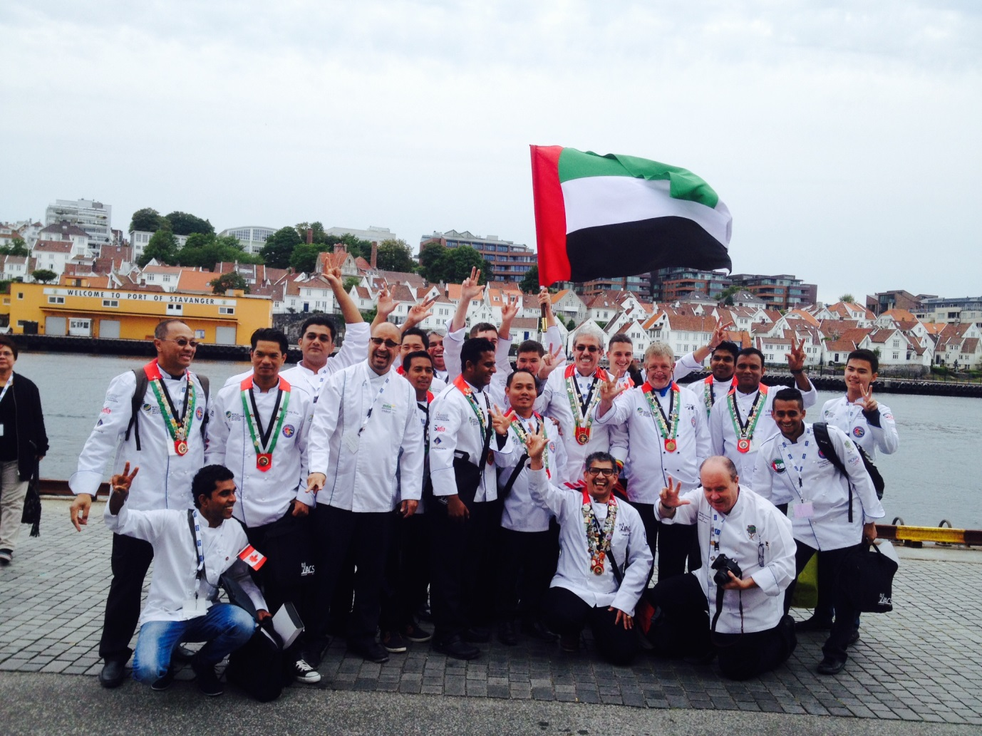

**UAE Chefs at the World Congress in Stavanger Norway**

A delegation of 31 Chefs from United Arab Emirates had joined the World Congress of Chefs. The Chairman of the Emirates Culinary Guild and General Manager Madinat Jumeirah C&I, Jumeirah Hospitality, Andy Cuthbert who is also heading the World Chefs Global Committee for Young chefs development said “*One of the key experiences was that the Congress gave over 50 Young Chefs from all over the World the opportunity to experience a Congress, a new country and the chance to form lifelong bonds. These are Chefs who will take over the World Chefs in the future. It was very exciting at the Bill Gallagher Young Chefs Forum”*

Chef Uwe Micheel, the President of the Emirates Culinary Guild and Director of Kitchens at the Radisson Blu Hotel Dubai Deira Creek, who is also a member of Jury who judged the Global Chef Competition, committed on amazing High Standard in all the 3 World Finals. The Global Chef, The Global Pastry Chef and Hans Bueshckens Young Chef competition had 7 finalist each, the Winner from each Continent.

The representative in the global Pastry Chef Competition for Middle East and Africa was Achala Weeransinghe from Madinat Jumeirah. Chef Achala achieved to become the 4th best Pastry Chef in the world wide competition. The representative in the Hans Bueschkens Young Chef Competition was Rahil Rathod from Radisson Blu Hotel Dubai Deira Creek. Chef Rahil has come 4th in the world final.

Both Chefs started the competition 1 ½ years back by first winning In Dubai, then UAE after they went to Continental Semi-finals in Namibia where both won the right to compete for Middle East Africa (MEA)

Chef Uwe also commented on Educational Program during the World Congress. It was really a good balance just to name a few Dilmah Tea Seminar, Sessions for Food and Beverage pairing, seminars for Sustainability, Chefs ‘responsibility for Fitness and Nutrition for themselves and the guests, the Art of Sous-Vide cooking or Session by a Chocolate Master

The Congress of World Chefs which was hosted by the ECG in Dubai World Trade Centre in 2008 is happening every 2 years and will be next in Athens, Greece in April 2016.